|  |  |  |  |  |  |  |
| --- | --- | --- | --- | --- | --- | --- |
| |  |  |  |  | | --- | --- | --- | --- | | **logo ngan.png** | | **MINISTRY OF EDUCATION AND TRAINING** | | | **FPT UNIVERSITY** | | |
| Capstone Project Document |
| Maid Services |
| |  |  |  |  |  |  |  |  |  |  |  | | --- | --- | --- | --- | --- | --- | --- | --- | --- | --- | --- | | |  |  | | --- | --- | | **Group 06 – Report 1** | | | **Group member** | Bùi Tiến Tuân - Team Leader - SE60824  Mạnh Quang Tuyến - Team Member - SE60890  Trương Hải Đăng - Team Member - SE60841  Nguyễn Tấn Công - Team Member - SE60920 | | **Supervisor** | Mr. Nguyễn Trọng Tài | | **Ext. Supervisor** | N/A | | **Capstone Project code** | MS | | |

-Ho Chi Minh City, 09/2014-

# Table of Contents

Table of Contents 2

2.1 User Requirement Specification 3

2.1.1 Guest requirement 3

2.1.2 Web member requirement 4

2.1.3 Webmaster requirement 4

2.1.4 Boss requirement 4

2.1.5 Player requirement 5

2.1.6 Coach requirement 5

2.1.7 System requirement 5

2.2 System Requirement Specification 6

2.2.1 External Interface Requirements 6

2.2.1.1 User Interfaces 6

2.2.1.2 Hardware Interfaces 6

2.2.1.3 Software Interfaces 6

2.2.1.4 Communications Protocol 6

2.2.2 System Features 6

2.2.2.1 List of use case 6

2.2.2.2 Use Case model: 8

2.2.2.3 Use-case diagram 10

2.2.3 Software System Attributes 153

2.2.3.1 Reliability 153

2.2.3.2 Availability 153

2.2.3.3 Security 153

2.2.3.4 Maintainability 153

2.2.3.5 Portability 153

2.2.3.6 Performance 153

2.3 Entity Relationship Diagram or Data Structures 154

2.4 Other material (if any) 154



## User Requirement Specification

|  |  |
| --- | --- |
| Actor | Description |
| **Guest** | A person not login. They have some simple function search. |
| **Staff** | A person help staff and customer connect together and post job request for Maid |
| **Customer** | Hiring maids. They can search, comment rating for job request posted by Maid or Maid Mediator. |
| **Maid Mediator** | They help maid post job request. |
| **Maid** | They can post job request. |
| **Webmaster** | They manager website. |
| **System** | Implement suggestions. |

### Guest requirement

To satisfy the demand of guest, system has these functions:

* **Register account:** guest need to register to become member.
* **Login**: when guest have account they can login with username and password.
* **Search jobs:** guest can search information about jobs, before they determine become a member.

### Staff requirement

A person: to manage the maid’s request, fee and allow maid to post request.

* **Manage post time**: staff manage maid’s request post time.
* **View post time**: staff can allow customer and maid the time that maid’s request posted.
* **Manage fee**: staff can manage the customer’s fee, maid’s fee
* **Confirm request**: staff can allow the maid’s request to post to the website.

### Customer requirement

A person:

* **Search maids**:
* **Rating**:
* **Comment**:
* **Manage recruitment**:
* **View customer statistic**:

### Maid mediator requirement

A person:

* **Apply job**:
* **Search jobs**:
* **Manage job request**:
* **View maid statistic**:

### Maid requirement

A person:

* **M**:

### Webmaster requirement

A person:

* **Manager user**:

### System requirement

A person:

* **Suggests**:
* **Handle unconfirmed request**:
* **Notify**:

## System Requirement Specification

### External Interface Requirements

#### User Interfaces

* The general interface of website is simple and simplifies user interfaces.
* The design is simple and monochrome is more prefer.
* The layout of information in page is showing simple but full of functions.
* The error, warning and notification messages must be simple, neat, and easy to understand. Error warning does not discomfort to the user.
* The working layout of user is spacious.
* Member can contact with manager and admin easily.

#### Hardware Interfaces

There is no extra hardware interfaces are needed. The system will use the standard hardware and data communications resources of a standard computer.

#### Software Interfaces

Browsers: Firefox, Chrome

#### Communications Protocol

BSF website uses HTTP/HTTPS protocol for communication with the web browser and the web server. In addition, TCP/IP network protocol for communication with HTTP protocol

### System Features

#### List of use case

|  |  |  |  |  |  |  |  |  |  |
| --- | --- | --- | --- | --- | --- | --- | --- | --- | --- |
| No. | Use case name | Use case ID | Guest | Staff | Customer | Maid mediator | Authenticad user | Webmaster | System |
| 1 | Register account | 001 | x |  |  |  |  |  |  |
| 2 | Login | 002 | x |  |  |  |  |  |  |
| 3 | Search | 003 | x |  |  |  |  |  |  |
| 4 | Manage post time | 004 |  | x |  |  |  |  |  |
| 5 | Manage fee | 005 |  | x |  |  |  |  |  |
| 6 | Confirm request | 006 |  | x |  |  |  |  |  |
| 7 | Advance search maids | 007 |  |  | x |  |  |  |  |
| 8 | Manage recruitment | 008 |  |  | x |  |  |  |  |
| 9 | View customer statistic | 009 |  |  | x |  |  |  |  |
| 10 | Customer comment | 010 |  |  | x |  |  |  |  |
| 11 | Customer rating | 011 |  |  | x |  |  |  |  |
| 12 | Payment | 012 |  |  | x | x |  |  |  |
| 13 | Manage profile | 013 |  |  |  |  | x |  |  |
| 14 | Log out | 014 |  |  |  |  | x |  |  |
| 15 | Apply job request | 015 |  |  |  | x |  |  |  |
| 16 | Manage job request | 016 |  |  |  | x |  |  |  |
| 17 | Advance search jobs | 017 |  |  |  | x |  |  |  |
| 18 | View maid statistic | 018 |  |  |  | x |  |  |  |
| 19 | Suggests | 019 |  |  |  |  |  |  | x |
| 20 | Notify | 020 |  |  |  |  |  |  | x |
| 21 | Manage user | 021 |  |  |  |  |  | x |  |
| 22 |  | 022 |  |  |  |  |  |  |  |
| 23 |  | 023 |  |  |  |  |  |  |  |
| 24 |  | 024 |  |  |  |  |  |  |  |
| 25 |  | 025 |  |  |  |  |  |  |  |
| 26 |  | 026 |  |  |  |  |  |  |  |
| 27 |  | 027 |  |  |  |  |  |  |  |
| 28 |  | 028 |  |  |  |  |  |  |  |
| 29 |  | 029 |  |  |  |  |  |  |  |
| 30 |  | 030 |  |  |  |  |  |  |  |
| 31 |  | 031 |  |  |  |  |  |  |  |
| 32 |  | 032 |  |  |  |  |  |  |  |
| 33 |  | 033 |  |  |  |  |  |  |  |
| 34 |  | 034 |  |  |  |  |  |  |  |
| 35 |  | 035 |  |  |  |  |  |  |  |
| 36 |  | 036 |  |  |  |  |  |  |  |
| 37 |  | 037 |  |  |  |  |  |  |  |
| 38 |  | 038 |  |  |  |  |  |  |  |
| 39 |  | 039 |  |  |  |  |  |  |  |
| 40 |  | 040 |  |  |  |  |  |  |  |
| 41 |  | 041 |  |  |  |  |  |  |  |
| 42 |  | 042 |  |  |  |  |  |  |  |
| 43 |  | 043 |  |  |  |  |  |  |  |
| 44 |  | 044 |  |  |  |  |  |  |  |
| 45 |  | 045 |  |  |  |  |  |  |  |
| 46 |  | 046 |  |  |  |  |  |  |  |
| 47 |  | 047 |  |  |  |  |  |  |  |
| 48 |  | 048 |  |  |  |  |  |  |  |

#### Use Case model:

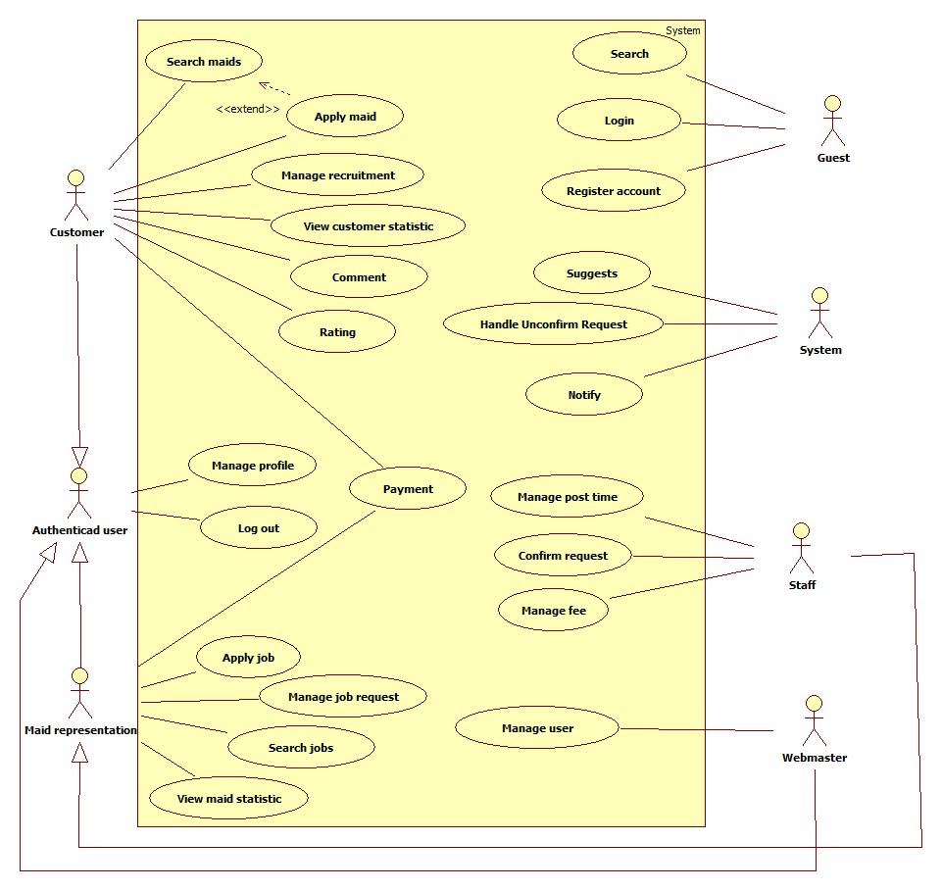

#### Use-case diagram

##### <Guest> Register

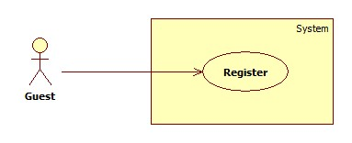

|  |  |  |  |  |
| --- | --- | --- | --- | --- |
| **USE CASE SPECIFICATION** | | | | |
| **Use-case No.** | UC001 | **Use-case Version** | | 1.0 |
| **Use-case Name** | Register | | | |
| **Author** | CongNT | | | |
| **Date** | 21/09/2014 | **Priority** | High | |
| **Actor:** Guest  **Summary:** This use case allows guest create an account in website system.  **Goal:**  It helps guest to create an account on website.  **Trigger:** Click on the “Đăng ký” button to register on home page  **Pre-conditions:**   * Page is loaded successfully * Register page will be shown   **Post conditions:**   * Success: Register successfully, guest will have an account in system and will be logged into system. * Failure: Show message error.   **Main Success Scenario:**   |  |  | | --- | --- | | Actor Action | System Response | | 1. Click on “Đăng ký” button home page 2. Input right information about username, email, password, full name, city, district, address, phone 3. Click on the “Đăng ký” button [Alternative 1] | 2. System redirect to register page for guest, contain a register form :   * Tên tài khoản [Username: textbox ] * Mật khẩu [Password : textbox] * Nhập lại mật khẩu [Repassword : textbox] * Địa chỉ email [Email: textbox]   In format: /^([a-zA-Z0-9_\.\-])+\@(([a-zA-Z0-9\-])+\.)+([a-zA-Z0-9]{2,4})+$/ .   * Họ và tên [Fullname : textbox] * Địa chỉ [Address : textbox] * Thành Phố [City : textbox] * Số điện thoại[Phone : textbox] * Đóng[button] * Đăng ký[button]  1. Validate valid username and check with the green check 2. Redirect to register success page [Exception 1,2 3,4] |   **Alternative Scenario:**   |  |  | | --- | --- | | Actor Action | System Response | | 1. [Alternative 1] Click on the “Đóng” button. | 1. Back to home page |   **Exceptions:**   |  |  | | --- | --- | | Actor Action | System Response | | 1. “Tên đăng nhập”,”Mật khẩu” ,”nhập lại mật khẩu” “Email” text-box is empty 2. When fills username is more than 32 characters or less than 6 characters 3. When user fills password is more than 32 characters or less than 6 characters 4. When user fills password and re-password different 5. User input wrong confirm captcha | 1. Display message:” Vui lòng nhập chính xác thông tin yêu cầu.” 2. Display message “Tên đăng nhập phải từ 6 đến 32 ký tự” 3. Display message “Mật khẩu trong khoảng từ 6-32 kí tự!” 4. Display message” Mật khẩu nhập lại chưa chính xác !” 5. Display message “Kết quả không chính xác, bạn hãy thử lại.” |   **Relationships:** N/A  **Business Rules:** N/A | | | | |

##### <System> Suggest

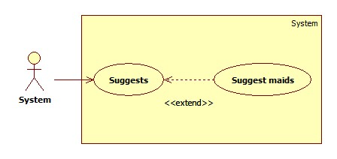

|  |  |  |  |  |
| --- | --- | --- | --- | --- |
| **USE CASE SPECIFICATION** | | | | |
| **Use-case No.** | UC019 | **Use-case Version** | | 1.0 |
| **Use-case Name** | Suggest maids | | | |
| **Author** | TuanBT | | | |
| **Date** | 24/09/2014 | **Priority** | High | |
| **Actor:** System  **Summary:** system automatically suggest maids for customer when they post a recruitment on MS-Website.  **Goal:**  The use case will help MS-Website suggest maids for customer when they post a recruitment.  **Trigger:**   * Click [Yêu cầu công việc] button. * Fill all data. * Click [Đăng yêu cầu] button.   **Pre-conditions:**   * Post an invalid recruitment.   **Post conditions:**   * Success: List maid will appear by suggestion criteria. * Failure: List maid upcoming will appear by create date order.   **Main Success Scenario:**   |  |  | | --- | --- | | Actor Action | System Response | | 1. User click on the [Đăng yêu cầu] button.   [Alternative 1] | 1. Show list jobs request by suggest criteria.   [Exception 1] |   **Alternative Scenario:**   |  |  | | --- | --- | | Actor Action | System Response | | 1. User click on the [Đăng yêu cầu] button. | 1. Show list jobs request by suggest criteria. |   **Exceptions:**   |  |  | | --- | --- | | Actor Action | System Response | | 1. System fail to load data | 1. Show list jobs request |   **Relationships:** N/A  **Business Rules:**  When customer post a recruitment, system calculate jobs request this nearer than recruitment. | | | | |

##### <System> Notify

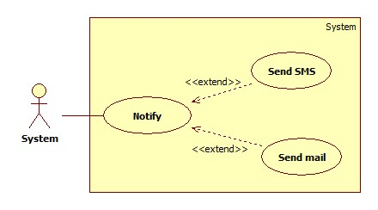

|  |  |  |  |  |
| --- | --- | --- | --- | --- |
| **USE CASE SPECIFICATION** | | | | |
| **Use-case No.** | UC020 | **Use-case Version** | | 1.0 |
| **Use-case Name** | Notify | | | |
| **Author** |  | | | |
| **Date** | 24/09/2014 | **Priority** | Normal | |
| **Actor:** System  **Summary:** Notify for Maid and Customer when they apply together.  **Goal:**  Send mail and SMS to Maid and Customer when apply. System know when accept a job.  **Trigger:** Both Customer and Maid post an invalid recruitment and job request. They apply together.  **Pre-conditions:**   * Apply success.   **Post conditions:**   * Success: Send email and SMS * Failure: An error message on screen   **Main Success Scenario:**   |  |  | | --- | --- | | Actor Action | System Response | | 1. System receive Customer and Maid apply | 2 Send email and SMS  [Exception 1] |   **Alternative Scenario:**   |  |  | | --- | --- | | Actor Action | System Response | | N/A | N/A |   **Exceptions:**   |  |  | | --- | --- | | Actor Action | System Response | | 1. Email or phone number is blank | 1. Show error “Không thể gửi email hoặc tin nhắn” |   **Relationships:** N/A  **Business Rules:** System must send email or SMS, help maid or customer know when request of them apply. | | | | |

##### <Guest> Login

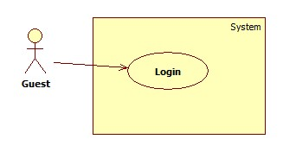

|  |  |  |  |  |
| --- | --- | --- | --- | --- |
| **USE CASE SPECIFICATION** | | | | |
| **Use-case No.** | UC002 | **Use-case Version** | | 1.0 |
| **Use-case Name** | Login | | | |
| **Author** | CongNT | | | |
| **Date** | 21/09/2014 | **Priority** | High | |
| **Actor:** Guest  **Summary:** This use case allow guest to login the website  **Goal:** Guest become a member of the website  **Trigger:** Click on the “Đăng nhập” button to login on home page  **Pre-conditions:**   * Page is loaded successfully * The login page will shown   **Post conditions:**   * Success: Login successfully, guest will have a role in system and can use more function of system. * Failure: Show message error   **Main Success Scenario:**   |  |  | | --- | --- | | Actor Action | System Response | | 1. Click on “Đăng nhập” button home page 2. Input right information about username, password 3. Click on the “Đăng nhập” button | 1. System redirect to login page for guest, contain a login form :  * Tên tài khoản [Username: textbox ] * Mật khẩu [Password : textbox] * Đóng [button] * Đăng nhập [button]  1. Redirect to login successful page |   **Alternative Scenario:**   |  |  | | --- | --- | | Actor Action | System Response | | 1. [Alternative 1] Click on the “Đóng” button. | 1. Back to home page |   **Exceptions:**   |  |  | | --- | --- | | Actor Action | System Response | | 1. “Tên đăng nhập”,”Mật khẩu” ,” is empty 2. “Tên đăng nhập”,”Mật khẩu” ,” is incorrect | 1. Display message “Vui lòng nhập tên đăng nhập và mật khẩu” 2. Display message “Tên đăng nhập hoặc mật khẩu không đúng, vui lòng thử lại” |   **Relationships:** N/A  **Business Rules:** N/A | | | | |

##### <Guest> Search

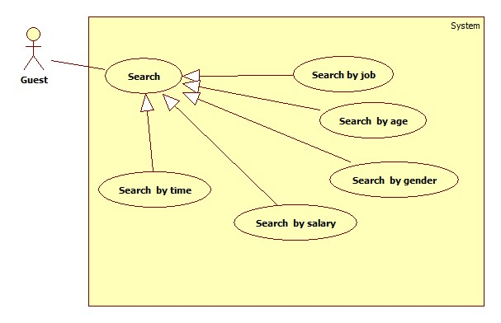

###### **<Guest> Search by job**

|  |  |  |  |  |
| --- | --- | --- | --- | --- |
| **USE CASE SPECIFICATION** | | | | |
| **Use-case No.** | UC003a | **Use-case Version** | | 1.0 |
| **Use-case Name** | Search by name | | | |
| **Author** | CongNT | | | |
| **Date** | 21/09/2014 | **Priority** | High | |
| **Actor:** Guest  **Summary:** This use case allow guest can search information by job  **Goal:** Guest can search information by search job  **Trigger:** Fill in “Tìm kiếm” textbox, then click on “Tìm kiếm” button  **Pre-conditions:**   * Page is loaded successfully * The search page will shown   **Post conditions:**   * Success: Search successfully, the system will shown search result * Failure:   **Main Success Scenario:**   |  |  | | --- | --- | | Actor Action | System Response | | 1. Fill in “Tìm kiếm” text box 2. Click on “Tìm kiếm” button 3. Click on “Nấu ăn” or “trông trẻ” link | 1. System redirect to search page for guest 2. Show the result suitable for each link |   **Alternative Scenario:**   |  |  | | --- | --- | | Actor Action | System Response | | 1. [Alternative 1] Click on the “Đóng” button. | 1. Back to home page |   **Exceptions:**   |  |  | | --- | --- | | Actor Action | System Response | |  |  |   **Relationships:** N/A  **Business Rules:** N/A | | | | |

###### **<Guest> Search by age**

|  |  |  |  |  |
| --- | --- | --- | --- | --- |
| **USE CASE SPECIFICATION** | | | | |
| **Use-case No.** | UC003a | **Use-case Version** | | 1.0 |
| **Use-case Name** | Search by age | | | |
| **Author** | CongNT | | | |
| **Date** | 21/09/2014 | **Priority** | High | |
| **Actor:** Guest  **Summary:** This use case allow guest can search information by age  **Goal:** Guest can search information by search age  **Trigger:** Fill in “Tìm kiếm” textbox, then click on “Tìm kiếm” button  **Pre-conditions:**   * Page is loaded successfully * The search page will shown   **Post conditions:**   * Success: Search successfully, the system will shown search result * Failure:   **Main Success Scenario:**   |  |  | | --- | --- | | Actor Action | System Response | | 1. Fill in “Tìm kiếm” text box 2. Click on “Tìm kiếm” button 3. Click on “25-30” or “30-35” or “35-40” link | 1. System redirect to search page for guest 2. Show the result suitable for each link |   **Alternative Scenario:**   |  |  | | --- | --- | | Actor Action | System Response | | 1. [Alternative 1] Click on the “Đóng” button. | 1. Back to home page |   **Exceptions:**   |  |  | | --- | --- | | Actor Action | System Response | |  |  |   **Relationships:** N/A  **Business Rules:** N/A | | | | |

###### **<Guest> Search by salary**

|  |  |  |  |  |
| --- | --- | --- | --- | --- |
| **USE CASE SPECIFICATION** | | | | |
| **Use-case No.** | UC003a | **Use-case Version** | | 1.0 |
| **Use-case Name** | Search by salary | | | |
| **Author** | CongNT | | | |
| **Date** | 21/09/2014 | **Priority** | High | |
| **Actor:** Guest  **Summary:** This use case allow guest can search information by salary  **Goal:** Guest can search information by search salary  **Trigger:** Fill in “Tìm kiếm” textbox, then click on “Tìm kiếm” button  **Pre-conditions:**   * Page is loaded successfully * The search page will shown   **Post conditions:**   * Success: Search successfully, the system will shown search result * Failure:   **Main Success Scenario:**   |  |  | | --- | --- | | Actor Action | System Response | | 1. Fill in “Tìm kiếm” text box 2. Click on “Tìm kiếm” button 3. Click on “Dưới 3 triệu” or “3-5 triệu” or “trên 5 triệu” link | 1. System redirect to search page for guest 2. Show the result suitable for each link |   **Alternative Scenario:**   |  |  | | --- | --- | | Actor Action | System Response | | 1. [Alternative 1] Click on the “Đóng” button. | 1. Back to home page |   **Exceptions:**   |  |  | | --- | --- | | Actor Action | System Response | |  |  |   **Relationships:** N/A  **Business Rules:** N/A | | | | |

###### **<Guest> Search by time**

|  |  |  |  |  |
| --- | --- | --- | --- | --- |
| **USE CASE SPECIFICATION** | | | | |
| **Use-case No.** | UC003a | **Use-case Version** | | 1.0 |
| **Use-case Name** | Search by time | | | |
| **Author** | CongNT | | | |
| **Date** | 21/09/2014 | **Priority** | High | |
| **Actor:** Guest  **Summary:** This use case allow guest can search information by time  **Goal:** Guest can search information by search time  **Trigger:** Fill in “Tìm kiếm” textbox, then click on “Tìm kiếm” button  **Pre-conditions:**   * Page is loaded successfully * The search page will shown   **Post conditions:**   * Success: Search successfully, the system will shown search result * Failure:   **Main Success Scenario:**   |  |  | | --- | --- | | Actor Action | System Response | | 1. Fill in “Tìm kiếm” text box 2. Click on “Tìm kiếm” button 3. Click on “Cách đây 1 ngày” or “Cách đây 3 ngày” or “Cách đây 5 ngày” or “Cách đây 7 ngày” or “Cách đây 14 ngày” or “Cách đây 30 ngày” link | 1. System redirect to search page for guest 2. Show the result suitable for each link |   **Alternative Scenario:**   |  |  | | --- | --- | | Actor Action | System Response | | 1. [Alternative 1] Click on the “Đóng” button. | 1. Back to home page |   **Exceptions:**   |  |  | | --- | --- | | Actor Action | System Response | |  |  |   **Relationships:** N/A  **Business Rules:** N/A | | | | |

###### **<Guest> Search by gender**

|  |  |  |  |  |
| --- | --- | --- | --- | --- |
| **USE CASE SPECIFICATION** | | | | |
| **Use-case No.** | UC003a | **Use-case Version** | | 1.0 |
| **Use-case Name** | Search by gender | | | |
| **Author** | CongNT | | | |
| **Date** | 21/09/2014 | **Priority** | High | |
| **Actor:** Guest  **Summary:** This use case allow guest can search information by gender  **Goal:** Guest can search information by search name  **Trigger:** Fill in “Tìm kiếm” textbox, then click on “Tìm kiếm” button  **Pre-conditions:**   * Page is loaded successfully * The search page will shown   **Post conditions:**   * Success: Search successfully, the system will shown search result * Failure:   **Main Success Scenario:**   |  |  | | --- | --- | | Actor Action | System Response | | 1. Fill in “Tìm kiếm” text box 2. Click on “Tìm kiếm” button 3. Click on “Nam” or “Nữ” link | 1. System redirect to search page for guest 2. Show the result suitable for each link |   **Alternative Scenario:**   |  |  | | --- | --- | | Actor Action | System Response | | 1. [Alternative 1] Click on the “Đóng” button. | 1. Back to home page |   **Exceptions:**   |  |  | | --- | --- | | Actor Action | System Response | |  |  |   **Relationships:** N/A  **Business Rules:** N/A | | | | |

##### <Guest> View jobs details

|  |  |  |  |  |
| --- | --- | --- | --- | --- |
| **USE CASE SPECIFICATION** | | | | |
| **Use-case No.** | UC003 | **Use-case Version** | | 1.0 |
| **Use-case Name** | View jobs details | | | |
| **Author** | CongNT | | | |
| **Date** | 21/09/2014 | **Priority** | Normal | |
| **Actor:** Guest  **Summary:** This use case allow guest to see jobs details  **Goal:** All jobs details are shown to guest  **Trigger:** Guest goes to visit the home page  **Pre-conditions:**   * Page is loaded successfully   **Post conditions:**   * Success: View all jobs details to guest   **Main Success Scenario:**   |  |  | | --- | --- | | Actor Action | System Response | | 1. Go to the home page of website | 2. View all Jobs details |   **Alternative Scenario:**   |  |  | | --- | --- | | Actor Action | System Response | | 1. Click on the “Đóng” button. | 1. Back to home page |   **Exceptions:**   |  |  | | --- | --- | | Actor Action | System Response | | 1. Server is busy or has problems | 1. Display message “Server hiện đang bận, xin vui lòng thử lại sau ít phút” |   **Relationships:** N/A  **Business Rules:** N/A | | | | |

##### <Staff> Manage post time

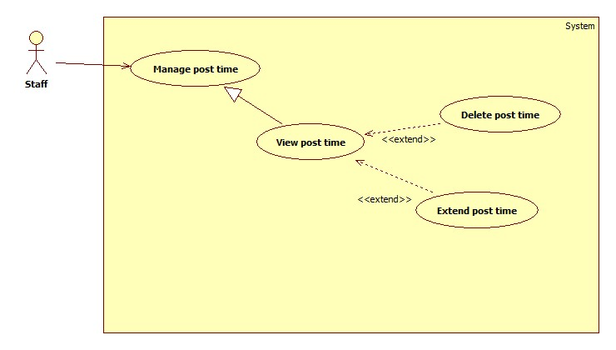

###### **<Staff> View post time**

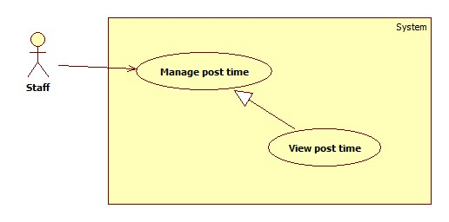

|  |  |  |  |  |
| --- | --- | --- | --- | --- |
| **USE CASE SPECIFICATION** | | | | |
| **Use-case No.** | UC004a | **Use-case Version** | | 1.0 |
| **Use-case Name** | View post time | | | |
| **Author** | CongNT | | | |
| **Date** | 21/09/2014 | **Priority** | High | |
| **Actor:** Staff  **Summary:** This use case allow staff to view post time to website for customer and maid  **Goal:** Staff can view and change post time for customer and maid  **Trigger:** User login as staff  **Pre-conditions:**   * Page is loaded successfully * User login as staff successful   **Post conditions:**   * Success: Login successfully, the system will shown list of post time * Failure: The system will shown message “The system is under maintain”   **Main Success Scenario:**   |  |  | | --- | --- | | Actor Action | System Response | | 1. Login as a staff | 1. System redirect to list of post time page |   **Alternative Scenario:**   |  |  | | --- | --- | | Actor Action | System Response | | 1. Click on the “Đăng xuất” button. | 1. Clear session and back to home page |   **Exceptions:**   |  |  | | --- | --- | | Actor Action | System Response | | 1. System fail to load data | 1. Show message “Hệ thống đang bảo trì” |   **Relationships:** N/A  **Business Rules:** Staff | | | | |

###### **<Staff> Delete post time**

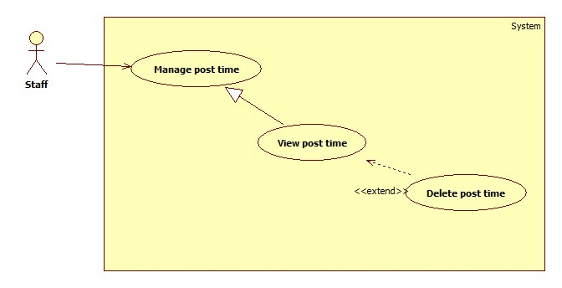

|  |  |  |  |  |
| --- | --- | --- | --- | --- |
| **USE CASE SPECIFICATION** | | | | |
| **Use-case No.** | UC004b | **Use-case Version** | | 1.0 |
| **Use-case Name** | Delete post time | | | |
| **Author** | CongNT | | | |
| **Date** | 21/09/2014 | **Priority** | High | |
| **Actor:** Staff  **Summary:** This use case allow staff to delete post time from website.  **Goal:** Staff can delete the post time of the customer and maid  **Trigger:** User login as staff  **Pre-conditions:**   * Page is loaded successfully * User login as staff successful * Post time page is loaded successful   **Post conditions:**   * Success: Delete successfully, the system will delete the post out the website and database, system send message “Dữ liệu đã được xóa” * Failure: The system will shown message “Không thể xóa bài này”   **Main Success Scenario:**   |  |  | | --- | --- | | Actor Action | System Response | | 1. Login as a staff 2. Click on “Xóa” button | 1. System redirect to list of post time page 2. System remove data out the website and database and show message “Dữ liệu đã được xóa” |   **Alternative Scenario:**   |  |  | | --- | --- | | Actor Action | System Response | | 1. Click on the “Đăng xuất” button. | 1. Clear session and back to home page |   **Exceptions:**   |  |  | | --- | --- | | Actor Action | System Response | | 1. System cannot remove data | 1. Show message “Không thể xóa dữ liệu này” |   **Relationships:** N/A  **Business Rules:** Staff | | | | |

###### **<Staff> Extend post time**

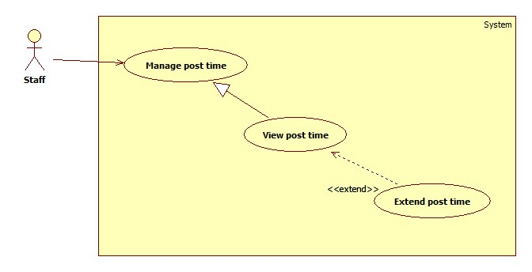

|  |  |  |  |  |
| --- | --- | --- | --- | --- |
| **USE CASE SPECIFICATION** | | | | |
| **Use-case No.** | UC004b | **Use-case Version** | | 1.0 |
| **Use-case Name** | Extend post time | | | |
| **Author** | CongNT | | | |
| **Date** | 21/09/2014 | **Priority** | High | |
| **Actor:** Staff  **Summary:** This use case allow staff to extend post time for customer and maid.  **Goal:** Staff can extend the post time for customer and maid  **Trigger:** User login as staff  **Pre-conditions:**   * Page is loaded successfully * User login as staff successful * Post time page is loaded successful   **Post conditions:**   * Success: Extend successfully, the system will delete the post out the website and database, system send message “Gia hạn thành công” * Failure: The system will shown message “Bài viết không thể gia hạn”   **Main Success Scenario:**   |  |  | | --- | --- | | Actor Action | System Response | | 1. Login as a staff 2. Click on “Gia hạn” button | 1. System redirect to list of post time page 2. System redirect a pop up contain extend form:  * Gia hạn đến ngày: [extend to: textbox] |   **Alternative Scenario:**   |  |  | | --- | --- | | Actor Action | System Response | | 1. Click on the “Đăng xuất” button. | 1. Clear session and back to home page |   **Exceptions:**   |  |  | | --- | --- | | Actor Action | System Response | | 1. System cannot extend data | 1. Show message “Không thể gia hạn bài viết này” |   **Relationships:** N/A  **Business Rules:** Staff | | | | |

##### <Staff> Manage fee

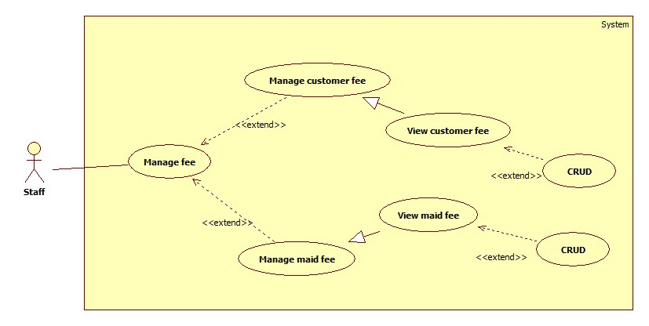

###### **<Staff> Manage customer fee**

**<Staff> View customer fee**

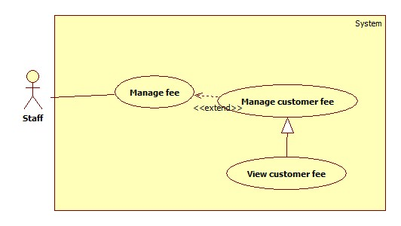

|  |  |  |  |  |
| --- | --- | --- | --- | --- |
| **USE CASE SPECIFICATION** | | | | |
| **Use-case No.** | UC005a | **Use-case Version** | | 1.0 |
| **Use-case Name** | View customer fee | | | |
| **Author** | CongNT | | | |
| **Date** | 21/09/2014 | **Priority** | High | |
| **Actor:** Staff  **Summary:** This use case view customer fee.  **Goal:** Staff view the customer fee  **Trigger:** User login as staff  **Pre-conditions:**   * Page is loaded successfully * User login as staff successful * Customer fee page is loaded successful   **Post conditions:**   * Success: View successfully, the system will view list of customer fee * Failure: The system will redirect post time page   **Main Success Scenario:**   |  |  | | --- | --- | | Actor Action | System Response | | 1. Login as a staff 2. Click on “Manage fee” button | 1. System redirect to list of post time page 2. System redirect tab “Phí khách hàng”, view list fee of customers. |   **Alternative Scenario:**   |  |  | | --- | --- | | Actor Action | System Response | | 1. Click on the “Quay lại” button. | 1. System return to post time page |   **Exceptions:**   |  |  | | --- | --- | | Actor Action | System Response | | 1. System cannot load data | 1. Show message “Không thể kết nối dữ liệu” |   **Relationships:** N/A  **Business Rules:** Staff | | | | |

**<Staff> CRUD customer fee**

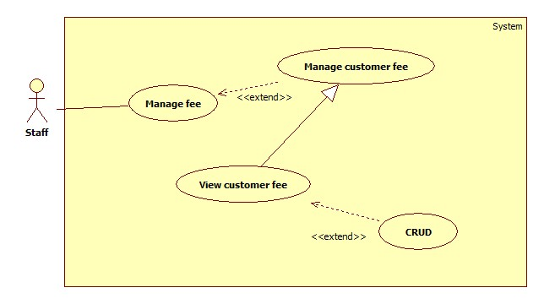

|  |  |  |  |  |
| --- | --- | --- | --- | --- |
| **USE CASE SPECIFICATION** | | | | |
| **Use-case No.** | UC005b | **Use-case Version** | | 1.0 |
| **Use-case Name** | CRUD customer fee | | | |
| **Author** | CongNT | | | |
| **Date** | 21/09/2014 | **Priority** | High | |
| **Actor:** Staff  **Summary:** This use case allow staff CRUD customer fee.  **Goal:** Staff can CRUD the customer fee  **Trigger:** User login as staff  **Pre-conditions:**   * Page is loaded successfully * User login as staff successful * Customer fee page is loaded successful   **Post conditions:**   * Success: CRUD successfully, the system will update the state of customer fee to database * Failure: The system will shown message “Không thể cập nhật”   **Main Success Scenario:**   |  |  | | --- | --- | | Actor Action | System Response | | 1. Login as a staff 2. Click on “Manage fee” button 3. Click on the post name of the of the customer 4. Input right information about fee 5. Click on “Cập nhập” or “Xóa” or “Đóng” button | 1. System redirect to list of post time page 2. System redirect tab “Phí khách hàng”, view list fee of customers. 3. System show the pop up has information of the customer, contain a form:  * Tên bài [Post name: textbox - read only] * Ngày đăng [JoinDate: date – read only] * Phí [Fee: float] * Cập nhật [button] * Đóng [button] * Xóa [button]  1. Validate valid fee and check with the green check 2. If click on “Cập nhật”, the system will show message “Cập nhật thành công”, if click on “Đóng”, system redirect to tab “Phí khách hàng”, if click on “Xóa”, system remove data from database and show message “Dữ liệu đã được xóa” and then redirect to tab “Phí khách hàng” |   **Alternative Scenario:**   |  |  | | --- | --- | | Actor Action | System Response | | 1. Click on the “Quay lại” button. | 1. System return to post time page |   **Exceptions:**   |  |  | | --- | --- | | Actor Action | System Response | | 1. System cannot update state of data | 1. Show message “Không thể cập nhật dữ liệu” |   **Relationships:** N/A  **Business Rules:** Staff | | | | |

###### **<Staff> Manage maid fee**

**<Staff> View maid fee**

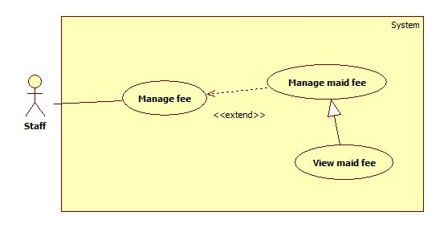

|  |  |  |  |  |
| --- | --- | --- | --- | --- |
| **USE CASE SPECIFICATION** | | | | |
| **Use-case No.** | UC005c | **Use-case Version** | | 1.0 |
| **Use-case Name** | View maid fee | | | |
| **Author** | CongNT | | | |
| **Date** | 21/09/2014 | **Priority** | High | |
| **Actor:** Staff  **Summary:** This use case view maid fee.  **Goal:** Staff view the maid fee  **Trigger:** User login as staff  **Pre-conditions:**   * Page is loaded successfully * User login as staff successful * Maid fee page is loaded successful   **Post conditions:**   * Success: View successfully, the system will view list of maid fee * Failure: The system will redirect post time page   **Main Success Scenario:**   |  |  | | --- | --- | | Actor Action | System Response | | 1. Login as a staff 2. Click on “Manage fee” button 3. Click on “Người giúp việc” tab | 1. System redirect to list of post time page 2. System redirect tab “Khách hàng”, view list fee of customers. 3. System redirect tab “Người giúp việc”, view list fee of maids. |   **Alternative Scenario:**   |  |  | | --- | --- | | Actor Action | System Response | | 1. Click on the “Quay lại” button. | 1. System return to post time page |   **Exceptions:**   |  |  | | --- | --- | | Actor Action | System Response | | 1. System cannot load data | 1. Show message “Không thể kết nối dữ liệu” |   **Relationships:** N/A  **Business Rules:** Staff | | | | |

**<Staff> CRUD maid fee**

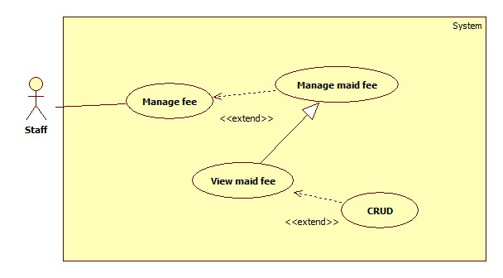

|  |  |  |  |  |
| --- | --- | --- | --- | --- |
| **USE CASE SPECIFICATION** | | | | |
| **Use-case No.** | UC005d | **Use-case Version** | | 1.0 |
| **Use-case Name** | CRUD maid fee | | | |
| **Author** | CongNT | | | |
| **Date** | 21/09/2014 | **Priority** | High | |
| **Actor:** Staff  **Summary:** This use case allow staff CRUD maid fee.  **Goal:** Staff can CRUD the maid fee  **Trigger:** User login as staff  **Pre-conditions:**   * Page is loaded successfully * User login as staff successful * Maid fee page is loaded successful   **Post conditions:**   * Success: CRUD successfully, the system will update the state of maid fee to database * Failure: The system will shown message “Không thể cập nhật”   **Main Success Scenario:**   |  |  | | --- | --- | | Actor Action | System Response | | 1. Login as a staff 2. Click on “Quản lý phí” button 3. Click on “Người giúp việc” tab 4. Click on the post name of the of the maid 5. Input right information about fee 6. Click on “Cập nhập” or “Xóa” or “Đóng” button | 1. System redirect to list of post time page 2. System redirect tab “Khách hàng”, view list fee of customers. 3. System redirect tab “Người giúp việc”, view list fee of maid. 4. System show the pop up has information of the maid, contain a form:  * Tên bài [Post name: textbox - read only] * Ngày đăng [JoinDate: date – read only] * Phí [Fee: float] * Cập nhật [button] * Đóng [button] * Xóa [button]  1. Validate valid fee and check with the green check 2. If click on “Cập nhật”, the system will show message “Cập nhật thành công”, if click on “Đóng”, system redirect to tab “Phí khách hàng”, if click on “Xóa”, system remove data from database and show message “Dữ liệu đã được xóa” and then redirect to tab “Người giúp việc” |   **Alternative Scenario:**   |  |  | | --- | --- | | Actor Action | System Response | | 1. Click on the “Quay lại” button. | 1. System return to post time page |   **Exceptions:**   |  |  | | --- | --- | | Actor Action | System Response | | 1. System cannot update state of data | 1. Show message “Không thể cập nhật dữ liệu” |   **Relationships:** N/A  **Business Rules:** Staff | | | | |

* + - * 1. **<Maid mediator> Apply job**



|  |  |  |  |  |
| --- | --- | --- | --- | --- |
| **USE CASE SPECIFICATION** | | | | |
| **Use-case No.** | UC021 | **Use-case Version** | | 1.0 |
| **Use-case Name** | Apply job | | | |
| **Author** | TuyenMQ | | | |
| **Date** | 03/10/2014 | **Priority** | High | |
| **Actor:** Maid mediator  **Summary:** This use case allow maid mediator to apply job.  **Goal:** Maid mediator can apply a job for a maid.  **Trigger:** User click on button “Nhận”  **Pre-conditions:**   * Page is loaded successfully * User login as maid mediator successful * Job request detail is loaded successful   **Post conditions:**   * Success: Apply job successfully, the system will update the status of job request in database * Failure: The system will shown message “Không thể nhận”   **Main Success Scenario:**   |  |  | | --- | --- | | Actor Action | System Response | | 1. Login as a maid mediator 2. Click on the job request in the “Chưa được nhận” tab 3. Click on “Nhận” button | 1. System redirects to maid mediator page 2. System redirects job request detail page. 3. Text “Đã chấp nhận” shows up at “Tình trạng” and the button “Nhận” disappear. |   **Alternative Scenario:**   |  |  | | --- | --- | | Actor Action | System Response | | 1. Click on the “Quay lại” button. | 1. System return to maid mediator page |   **Exceptions:**   |  |  | | --- | --- | | Actor Action | System Response | | 1. System cannot update state of data | 1. Show message “Không thể cập nhật dữ liệu” |   **Relationships:** N/A  **Business Rules:** Maid mediator | | | | |

* + - * 1. **<Maid mediator> Search by job**



|  |  |  |  |  |
| --- | --- | --- | --- | --- |
| **USE CASE SPECIFICATION** | | | | |
| **Use-case No.** | UC022 | **Use-case Version** | | 1.0 |
| **Use-case Name** | Search job | | | |
| **Author** | TuyenMQ | | | |
| **Date** | 03/10/2014 | **Priority** | High | |
| **Actor:** Maid mediator  **Summary:** This use case allow maid mediator to search job by required job skill.  **Goal:** Maid mediator can get a list of jobs with expected job skill.  **Trigger:** User click on button “Tìm kiếm”  **Pre-conditions:**   * Page is loaded successfully * User login as maid mediator successful   **Post conditions:**   * Success: A list of expected jobs is displayed. * Failure: The system will shown message “Không tìm thấy”.   **Main Success Scenario:**   |  |  | | --- | --- | | Actor Action | System Response | | 1. Login as a maid mediator 2. Fill the text field with a job skill and click “Tìm kiếm” button | 1. System redirects to maid mediator page 2. System displays a list of jobs. |   **Alternative Scenario:**   |  |  | | --- | --- | | Actor Action | System Response | |  |  |   **Exceptions:**   |  |  | | --- | --- | | Actor Action | System Response | |  |  |   **Relationships:** N/A  **Business Rules:** Maid mediator | | | | |

* + - * 1. **<Maid mediator> View job request**



|  |  |  |  |  |
| --- | --- | --- | --- | --- |
| **USE CASE SPECIFICATION** | | | | |
| **Use-case No.** | UC023 | **Use-case Version** | | 1.0 |
| **Use-case Name** | View job request | | | |
| **Author** | TuyenMQ | | | |
| **Date** | 03/10/2014 | **Priority** | High | |
| **Actor:** Maid mediator  **Summary:** This use case allow maid mediator to view his/her posted job requests.  **Goal:** Maid mediator can view his/her posted job requests.  **Trigger:** User logs in as maid mediator.  **Pre-conditions:**   * Page is loaded successfully. * User login as maid mediator successful. * Job request detail is loaded successful.   **Post conditions:**   * Success: Change job request successfully, the system updates database. * Failure: Shows message “Thay đổi thất bại”.   **Main Success Scenario:**   |  |  | | --- | --- | | Actor Action | System Response | | 1. Login as a maid mediator 2. User clicks on a job request in the tab “Chưa được nhận” 3. User clicks on “Thay đổi” button 4. User changes the info in the text field as wanted and clicks on “Lưu” button | 1. System redirects to maid mediator page 2. System redirects to job request detail page 3. System redirects to job request changing page with all the info are displayed in text fields 4. System redirects to maid mediator page |   **Alternative Scenario:**   |  |  | | --- | --- | | Actor Action | System Response | |  |  |   **Exceptions:**   |  |  | | --- | --- | | Actor Action | System Response | |  |  |   **Relationships:** N/A  **Business Rules:** Maid mediator | | | | |

* + - * 1. **<Maid mediator> Change job request**



|  |  |  |  |  |
| --- | --- | --- | --- | --- |
| **USE CASE SPECIFICATION** | | | | |
| **Use-case No.** | UC024 | **Use-case Version** | | 1.0 |
| **Use-case Name** | Change job request | | | |
| **Author** | TuyenMQ | | | |
| **Date** | 03/10/2014 | **Priority** | High | |
| **Actor:** Maid mediator  **Summary:** This use case allow maid mediator to change his/her posted job requests.  **Goal:** Maid mediator can change his/her posted job requests.  **Trigger:** User click on “Thay đổi” button in job request detail page.  **Pre-conditions:**   * Page is loaded successfully. * User login as maid mediator successful.   **Post conditions:**   * Success: A list of job requests is displayed with 3 tabs “Đã được nhận”, “Chưa được nhận”, “Hết hạn”. * Failure: List of job requests is not displayed.   **Main Success Scenario:**   |  |  | | --- | --- | | Actor Action | System Response | | 1. Login as a maid mediator | 1. System redirects to maid mediator page 2. System displays a list of job requests with 3 tabs “Đã được nhận”, “Chưa được nhận”, “Hết hạn”. |   **Alternative Scenario:**   |  |  | | --- | --- | | Actor Action | System Response | | 1. Click on the “Quay lại” button. | 1. System return to maid mediator page |   **Exceptions:**   |  |  | | --- | --- | | Actor Action | System Response | | 1. System cannot update state of data | 1. Show message “Không thể cập nhật dữ liệu” |   **Relationships:** N/A  **Business Rules:** Maid mediator | | | | |

* + - * 1. **<Maid mediator> Post job request**



|  |  |  |  |  |
| --- | --- | --- | --- | --- |
| **USE CASE SPECIFICATION** | | | | |
| **Use-case No.** | UC025 | **Use-case Version** | | 1.0 |
| **Use-case Name** | Post job request | | | |
| **Author** | TuyenMQ | | | |
| **Date** | 03/10/2014 | **Priority** | High | |
| **Actor:** Maid mediator  **Summary:** This use case allow maid mediator to post a new job request.  **Goal:** Maid mediator can post a new job request.  **Trigger:** User click on “Đăng” button in maid mediator page.  **Pre-conditions:**   * Page is loaded successfully. * User login as maid mediator successful.   **Post conditions:**   * Success: Post job request successfully. System add new job request to database. * Failure: Show message “Đăng thất bại”.   **Main Success Scenario:**   |  |  | | --- | --- | | Actor Action | System Response | | 1. Login as a maid mediator 2. User clicks on “Đăng” button 3. User fills all the text fields and click “Lưu” button | 1. System redirects to maid mediator page 2. System redirects to job request posting page |   **Alternative Scenario:**   |  |  | | --- | --- | | Actor Action | System Response | | 1. Click on the “Quay lại” button. | 1. System return to maid mediator page |   **Exceptions:**   |  |  | | --- | --- | | Actor Action | System Response | | 1. System cannot update state of data | 1. Show message “Không thể cập nhật dữ liệu” |   **Relationships:** N/A  **Business Rules:** Maid mediator | | | | |

* + - * 1. **<Authenticated user> Manage profile**



|  |  |  |  |  |
| --- | --- | --- | --- | --- |
| **USE CASE SPECIFICATION** | | | | |
| **Use-case No.** | UC026 | **Use-case Version** | | 1.0 |
| **Use-case Name** | Manage profile | | | |
| **Author** | TuyenMQ | | | |
| **Date** | 03/10/2014 | **Priority** | High | |
| **Actor:** Authenticated user  **Summary:** This use case allow user to view profile.  **Goal:** User can view profile.  **Trigger:** User logins successfully.  **Pre-conditions:**   * Page is loaded successfully. * User logins successfully.   **Post conditions:**   * Success: System redirects to profile page. * Failure: Show message “Đăng nhập thất bại”.   **Main Success Scenario:**   |  |  | | --- | --- | | Actor Action | System Response | | 1. User logins | 1. System redirects to profile page |   **Alternative Scenario:**   |  |  | | --- | --- | | Actor Action | System Response | |  |  |   **Exceptions:**   |  |  | | --- | --- | | Actor Action | System Response | |  |  |   **Relationships:** N/A  **Business Rules:** Authenticated user | | | | |

* + - * 1. **<Authenticated user> Edit profile**



|  |  |  |  |  |
| --- | --- | --- | --- | --- |
| **USE CASE SPECIFICATION** | | | | |
| **Use-case No.** | UC026 | **Use-case Version** | | 1.0 |
| **Use-case Name** | Edit info | | | |
| **Author** | TuyenMQ | | | |
| **Date** | 03/10/2014 | **Priority** | High | |
| **Actor:** Authenticated user  **Summary:** This use case allow user to edit profile.  **Goal:** User can edit profile.  **Trigger:** User clicks on “Thay đổi” button in profile page.  **Pre-conditions:**   * Page is loaded successfully. * User logins successfully. * Profile editing page loads successfully.   **Post conditions:**   * Success: Edit profile successfully. The system updates database * Failure: Show message “Thay đổi thất bại”.   **Main Success Scenario:**   |  |  | | --- | --- | | Actor Action | System Response | | 1. User logins 2. User clicks on “Thay đổi” button 3. User changes all the text fields as wanted and click “Lưu” button | 1. System redirects to profile page 2. System redirects to profile editing page with all the info are displayed in text fields 3. System redirects to profile page |   **Alternative Scenario:**   |  |  | | --- | --- | | Actor Action | System Response | | 1. Click on the “Quay lại” button. | 1. System return to maid mediator page |   **Exceptions:**   |  |  | | --- | --- | | Actor Action | System Response | | 1. System cannot update state of data | 1. Show message “Không thể cập nhật dữ liệu” |   **Relationships:** N/A  **Business Rules:** Authenticated user | | | | |

* + - * 1. **<Authenticated user> Change password**



|  |  |  |  |  |
| --- | --- | --- | --- | --- |
| **USE CASE SPECIFICATION** | | | | |
| **Use-case No.** | UC027 | **Use-case Version** | | 1.0 |
| **Use-case Name** | Change password | | | |
| **Author** | TuyenMQ | | | |
| **Date** | 03/10/2014 | **Priority** | High | |
| **Actor:** Authenticated user  **Summary:** This use case allow user to change password.  **Goal:** User can change password.  **Trigger:** User clicks on “Đổi mật khẩu” button in profile page.  **Pre-conditions:**   * Page is loaded successfully. * User logins successfully. * Password changing page loads successfully.   **Post conditions:**   * Success: Change password successfully. The system updates database * Failure: Show message “Thay đổi thất bại”.   **Main Success Scenario:**   |  |  | | --- | --- | | Actor Action | System Response | | 1. User logins 2. User clicks on “Đổi mật khẩu” button 3. User fills 2 text fields and click “Lưu” button | 1. System redirects to profile page 2. System redirects to password changing page displaying 2 text fields require user to input old password and new password 3. System redirects to profile page |   **Alternative Scenario:**   |  |  | | --- | --- | | Actor Action | System Response | | 1. Click on the “Quay lại” button. | 1. System return to maid mediator page |   **Exceptions:**   |  |  | | --- | --- | | Actor Action | System Response | | 1. System cannot update state of data | 1. Show message “Không thể cập nhật dữ liệu” |   **Relationships:** N/A  **Business Rules:** Authenticated user | | | | |

* + - * 1. **<Authenticated user> Log out**



|  |  |  |  |  |
| --- | --- | --- | --- | --- |
| **USE CASE SPECIFICATION** | | | | |
| **Use-case No.** | UC028 | **Use-case Version** | | 1.0 |
| **Use-case Name** | Log out | | | |
| **Author** | TuyenMQ | | | |
| **Date** | 03/10/2014 | **Priority** | High | |
| **Actor:** Authenticated user  **Summary:** This use case allow user to log out  **Goal:** User can log out.  **Trigger:** User clicks on “Đăng xuất” link.  **Pre-conditions:**   * Page is loaded successfully. * User logins successfully.   **Post conditions:**   * Success: Log out successfully. The system redirects to homepage. * Failure:   **Main Success Scenario:**   |  |  | | --- | --- | | Actor Action | System Response | | 1. User clicks on “Log out” link | 1. System redirects to homepage |   **Alternative Scenario:**   |  |  | | --- | --- | | Actor Action | System Response | |  |  |   **Exceptions:**   |  |  | | --- | --- | | Actor Action | System Response | |  |  |   **Relationships:** N/A  **Business Rules:** Authenticated user | | | | |

### Software System Attributes

#### Reliability

* There is no requirement for system maintenance task from the user.
* Mean Time Between Failures (MTBF): more than 6 months.
* Accuracy: 100%.
* Maximum Bugs and Defect Rate: 0.3 bugs per thousand lines of code (0.3bugs/KLOC).
* Critical bugs:
* Loss of data: not any

#### Availability

* The server shall be working 24 hours per day and 7 days per week.

#### Security

* *All sensitive* information (password, etc.) must be hashed when storing in database and during transmission over networks using MD5 hash.
* Validate input data in SQL query before execute to avoid SQL Injection, XSS
* The role of user and member is clearly.

#### Maintainability

* All code shall fully document. All program files shall include comments concerning authorship and date of last change.
* The code shall be modular to permit future modifications.

#### Portability

* The software will design as cross-platform software.

#### Performance

* Large tables and indexes must be partitioned data into smaller, more manageable sections by using partition in SQL Server 2008 R2

## Entity Relationship Diagram or Data Structures

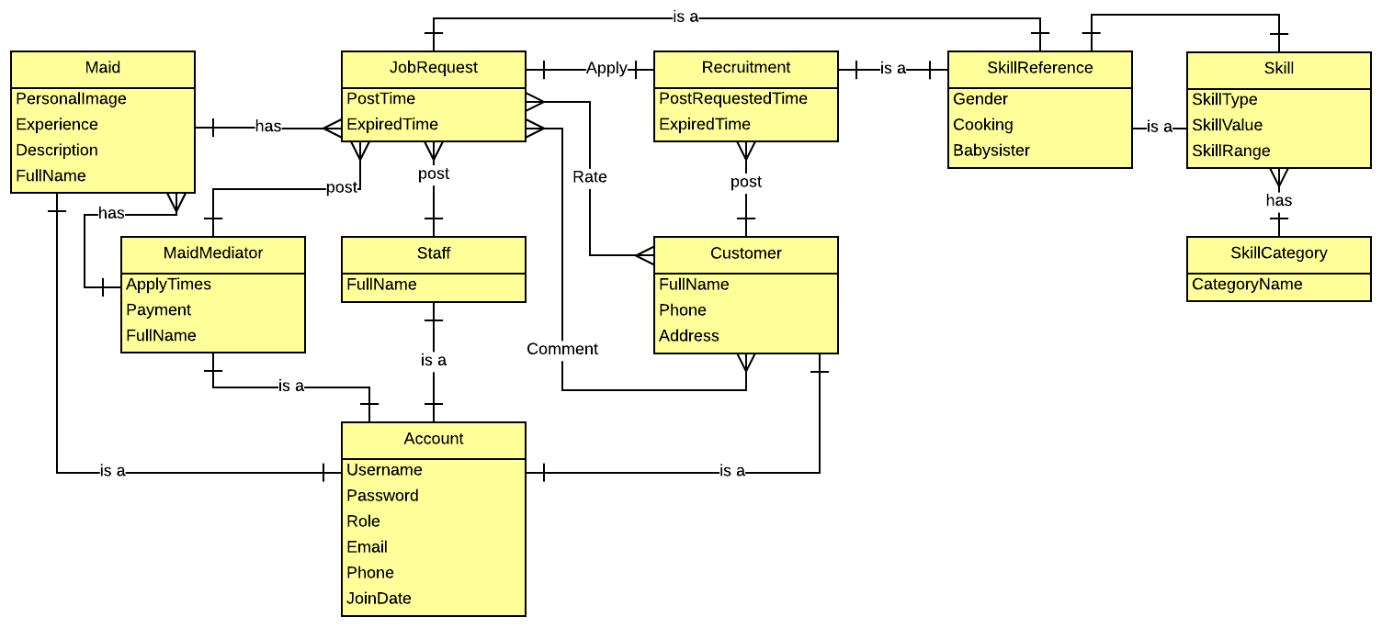

## Other material (if any)

N/A